FOUND DOG
MAX (if known)
Young Male Dog
Found on Jan 1, 2025
at Main St & 1st Ave in Ashland
Description: color, breed, markings (head, tail, ears, belly, paws), collar (color, design, no tag or tag with invalid contact)

Help Him Find His Way Home!

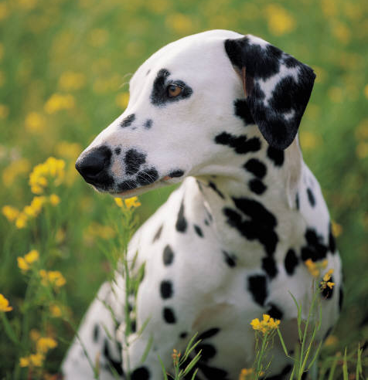

If you recognize this dog, please CALL IMMEDIATELY.

555-555-5555
FOUND DOG
555-555-5555
FOUND DOG
555-555-5555
FOUND DOG
555-555-5555
FOUND DOG
555-555-5555
FOUND DOG
555-555-5555
FOUND DOG
555-555-5555
FOUND DOG
555-555-5555
FOUND DOG
555-555-5555
FOUND DOG
555-555-5555
FOUND DOG
555-555-5555
FOUND DOG
555-555-5555
FOUND DOG
555-555-5555

